Requirement Document

7.3 Assertions Enhancement

7.3.1 Introduce @Assertions Option
A new @Assertions option should be introduced in Element dropdown of TSG.
Assertion Types
- HTTP Header Exists: Check if a specific HTTP header is present in the API response.
- HTTP Header Equals: Verify if a specific HTTP header’s value matches the expected value.
- Contains: Check if the response body contains a specified value or text.
- Not Contains: Ensure that the response body does not contain a specified value or text.
- Equals: Verify if the entire response or a specific element in the response matches an expected value.
- Status COde - Checks whether API returned expected HTTP status
- JSONPath Match Assertion - This assertion extracts a value from the JSON response using a JSONPath expression and validates it against an expected value.
- XMLPath Match Assertion - This assertion extracts a value from the XML response using a XMLPath expression and validates it against an expected value.
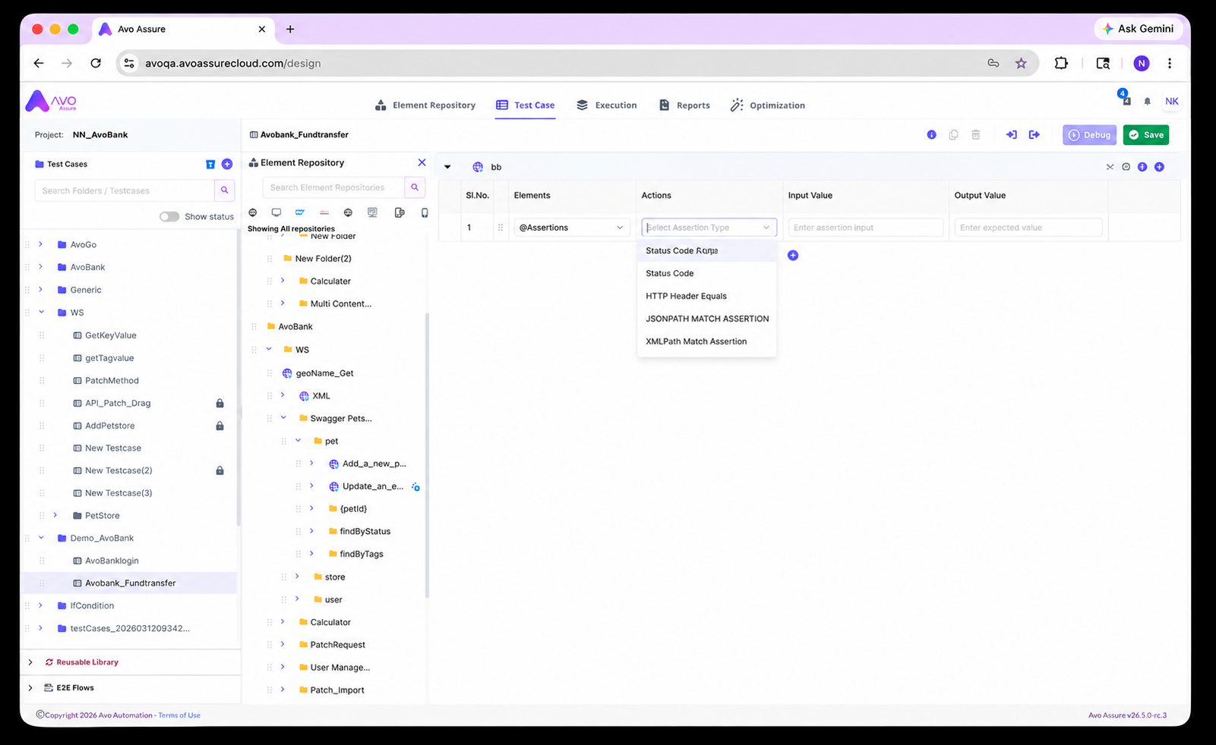

7.3.2 How to Add Assertions
- User clicks Element dropdown.
- User selects @Assertions option.
- Action dropdown displays all predefined assertion types.
- User selects required assertion.
- Popup/modal opens for assertion configuration.
- User enters assertion details.
- On clicking Add, assertion details populate into Input column.
- With this Response Validation step is added successfully in TSG
- Store the assertions variable and value in output variable.

8. Assertion Configuration Details

8.1 Status Code Assertion
Purpose: Validate HTTP response status code.
Field | Description
Expected Status Code | Enter expected response code
Example | 200
Output | Validation Pass/Fail.

8.2 Response Time Assertion
Purpose: Validate API response execution time.
Field | Description
Condition | Less Than / Greater Than
Time | Response time in ms
Example | 2000 ms
Output | Validation Pass/Fail

8.3 JSONPath Match Assertion
Purpose: Validate JSON response values using JSONPath.
Field | Description
JSONPath | JSONPath expression
Expected Value | Expected value
Example | $.data.id = 101
Output | Validation Pass/Fail

8.4 XMLPath Match Assertion
Purpose: Validate XML response values using XPath.
Field | Description
XPath | XPath expression
Expected Value | Expected value
Example | //book/id = 101
Output | Validation Pass/Fail

13. Acceptance Criteria
@Assertions option available in Element dropdown.
- Assertion popup opens successfully.
- Assertion details populate in Input column.
- Store the assertions variable and value in output variable
- Assertions execute successfully

This UI design is referred from ReadAPI Tool)
- 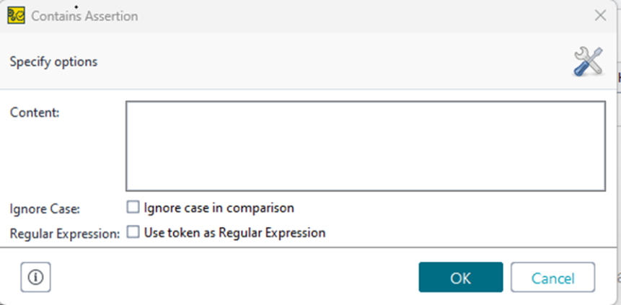
- 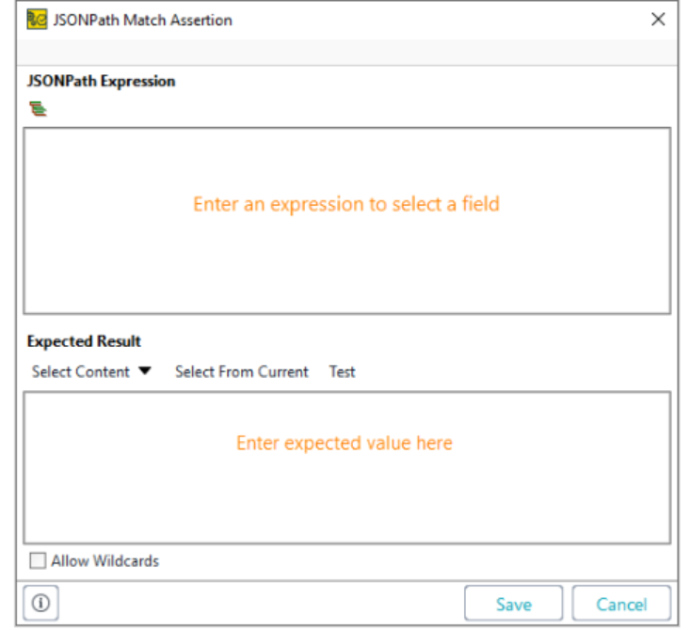
On click of this keypath builder will open where user can add the node and the Json expression will populate automatically
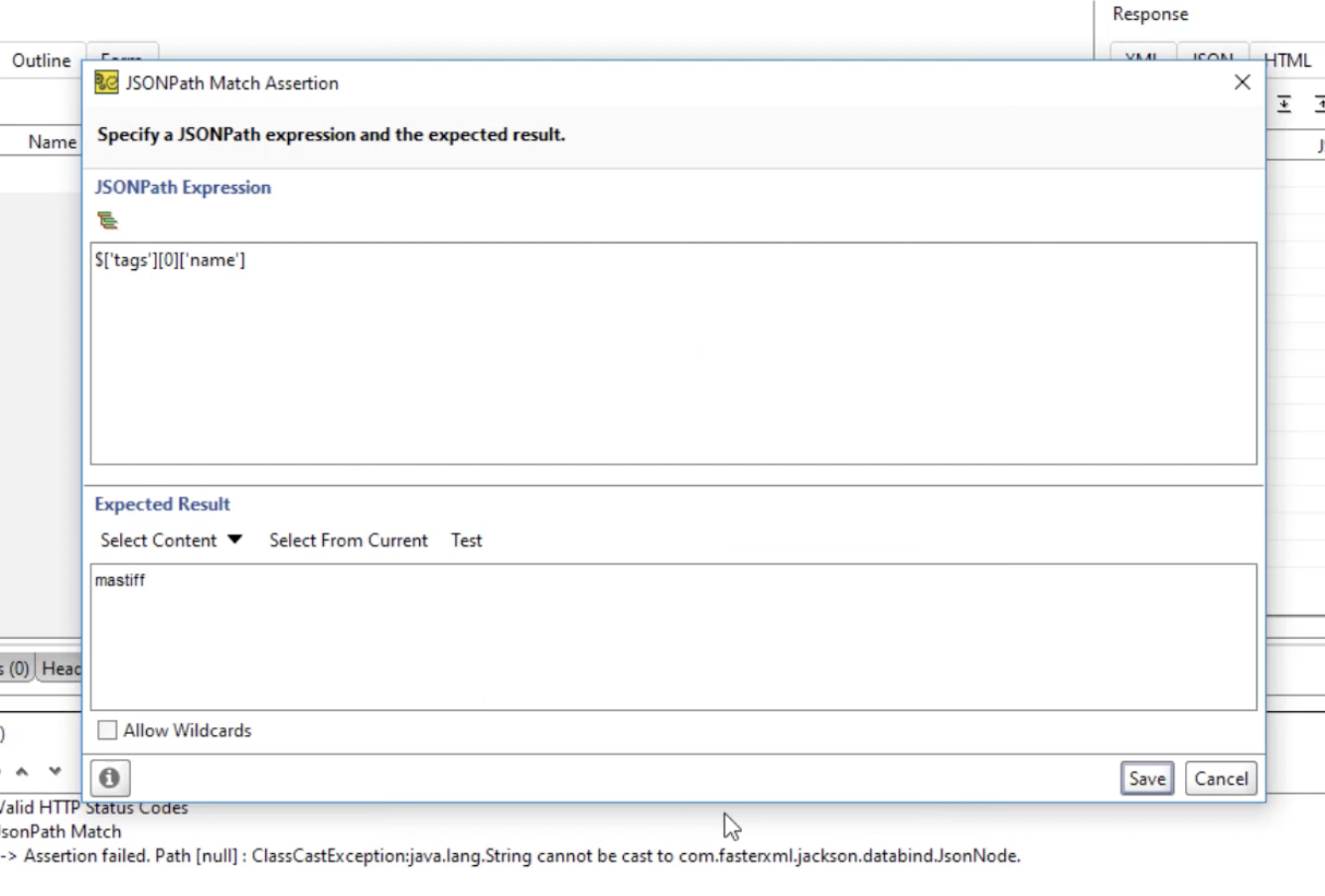
- https://www.youtube.com/watch?v=JqkXhy3Czrc

